Expanding Comfort Dog Ministry
Redeemer Lutheran Church
Spokane Valley, Washington
$5,000
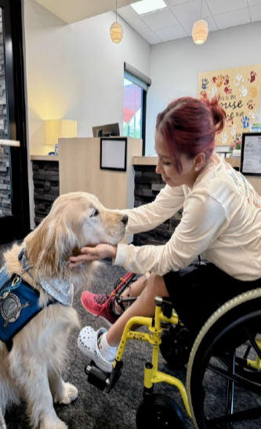
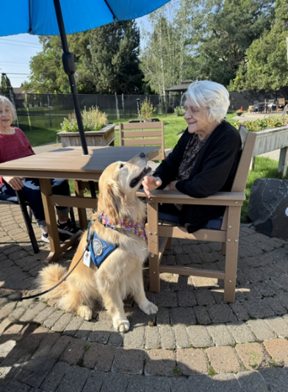
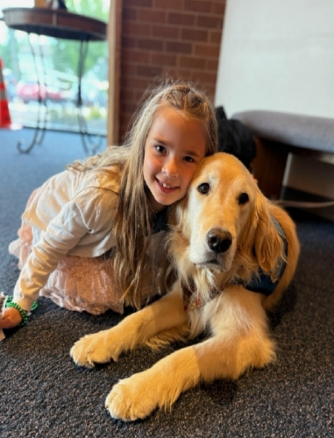
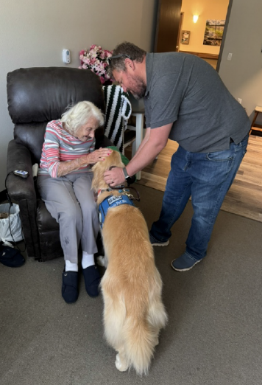

Redeemer Lutheran Church in Spokane Valley, Washington has been involved in the Lutheran Church Charities K-9 Comfort Dog Ministry since June 2020. Redeemer Lutheran began with Isaac Comfort Dog as the bridge to people outside the walls of the church to share the love of Christ with a hurting community. Isaac is busy and many requests for him must be turned down.
The $5,000 Mission Grant will assist in purchasing a second Comfort Dog, training a new team of handlers in Spiritual First Aid (to effectively help the needs of those encountered), and purchasing food, grooming and other essentials items for the second Comfort Dog.

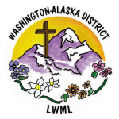
2026-2028 Biennium – LWML Washington-Alaska District

