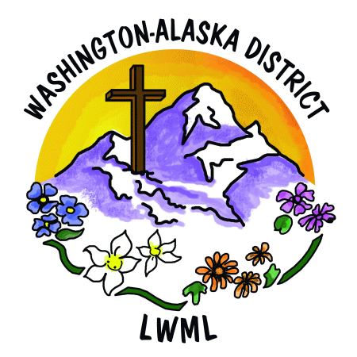
LWML Washington-Alaska District
2026-2028 Biennium Mission Grant Proposals

 | Mission Grant Proposals to be presented at the  35th Biennial Convention of LWML WA-AK District | Grant  Amount
1 | Aid to LWML Washington-Alaska District Scholarships | $16,000
2 | Aid to LWML Washington-Alaska District Short Term Missions | $5,000
3 | Bringing the Word to Light – Lutheran Braille Workers | $5,000
4 | Changed Lives, Shared Word – Lutheran Bible Translators | $2,500
5 | Christian Library Books for Sunbeams – Lutheran Church of the Cross, Kent, WA | $1,200
6 | Emergency Response Fund for Idaho Comfort Dog Ministry – Christ the King Lutheran Church, Coeur d’Alene, ID | $5,000
7 | Equipping and Sending Village Mission Teams with the Gospel – Alaska Mission for Christ | $5,000
8 | Equipping Church Workers to Bless International Students – International Student Ministry | $2,000
9 | Equipping God’s People to Proclaim the Messiah in Tel Aviv – Apple of His Eye Mission Society | $3,000
10 | Expanding Comfort Dog Ministry – Redeemer Lutheran Church, Spokane Valley, WA | $5,000
11 | Feet on the Ground – MOST Ministries | $3,000
12 | Gospel Outreach to Hispanics in the US – Lutheran Hour Ministries | $5,000
13 | Healing the Whole Child Bike Path – Dakota Boys and Girls Ranch | $2,000
14 | Hope for Suicide Awareness, Intervention, & Postvention – Lutherans for Life –  Word of Hope | $5,000
15 | House of Mercy Mission – Lutheran Ministry Services Northwest | $5,000
16 | LAMP 2026 Spring Fling – LAMP Ministry | $2,000
17 | Mental Health Prayer Book Ministry – Higher Things | $3,000
18 | Prayer and Service Deaconess Ministry – Lutheran Latino Ministries | $5,000
19 | Second Harvest Ministry to Hungry Families in Ferry County – Trinity Lutheran Church, Republic, WA | $4,000
20 | Sharing the Light of Christ through Five LCMS Missionaries – Mission Central, LCMS Mission Advancement | $10,000
21 | Worker Wellness for Chaplain Wives/Families – LCMS Ministry to the Armed Forces | $5,000

