Mail form to:
LWML WA-AK District Nominating Committee
Jayne Bowes, Chairman
PO Box 214
Okanogan, WA 98840
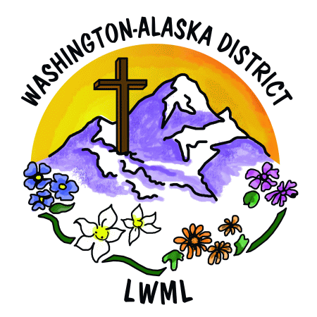
or email t0: jbinspire1@outlook.com

“God has given each of you a gift from his great variety of spiritual gifts. Use them well to serve one another” 1 Peter 4:10 (NLT).

Nominating Committee Members: Sandi Hall, Vikki Paulovic, Judy Peraino, Waverly Peterson.
Nomination Form
2026-2028 Biennium
I would like to place into nomination:
Name: ______________________________________________
Address ______________________________________________
______________________________________________________
Phone: _______________ Email: _________________________
To run for the office of: (Check office below)
- President
- Vice President of Organizational Resources
- Vice President of Special Focus Ministries
- Financial Secretary
- Pastoral Counselor-Eastside
- Nominating Committee
Signed (Person who is nominating) __________________________________
Print Name: _____________________________________________
Address: ________________________________________________
Phone: _________________ Email: _________________________

Deadline for nominations: April 1, 2026

