Feet on the Ground
MOST Ministries
$3,000
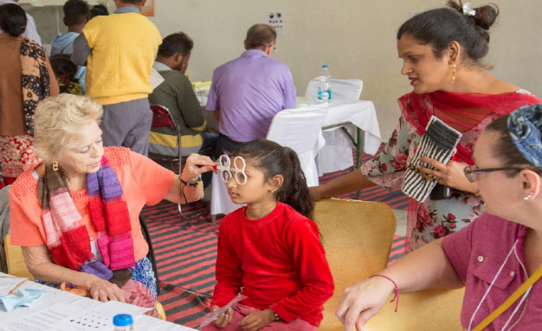
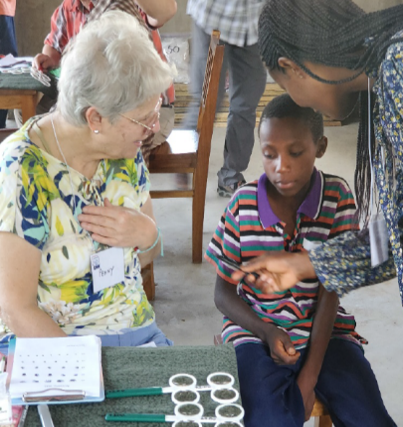
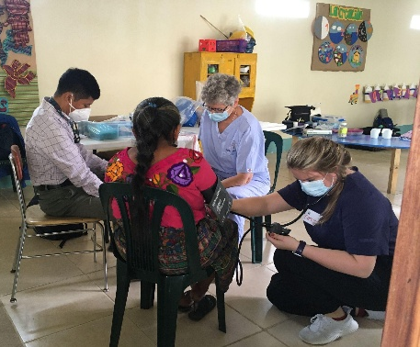

MOST Ministries enables Christians to go with short-term mission teams around the world to share the Gospel in word and deed – through eyeglass clinics, clean water projects, medical clinics, and other ministries.
Mission grant funds will be used as partial scholarships for LWML members joining their first MOST Ministries mission team. Funding will be applied to cover up to half the per-person cost of a mission team (up to $1500). The “Feet on the Ground” funds of this $3,000 grant will be awarded with preference given to members of the LWML Washington-Alaska District embarking on their first mission.

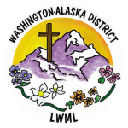
2026-2028 Biennium – LWML Washington-Alaska District

