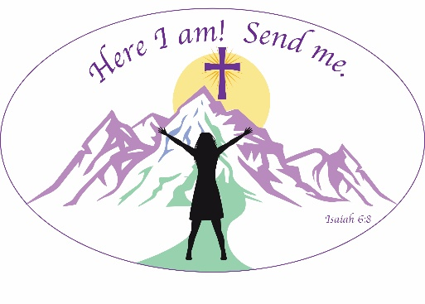
Please make your hotel reservations by June 9, directly with the Ruby River Hotel. The group name is Lutheran Women’s Missionary League 2026. Their phone number is 509-326-5577. The online link is available on the district website: wa-aklwml.org
LWML Washington-Alaska District Convention
July 10-12, 2026
Ruby River Hotel – Spokane, WA
REGISTRATION FORM
Please print and submit one form per registrant. If preferred, register online by clicking HERE
Name _______________________________________
Address _____________________________________
City ____________________ State _____ Zip ______
Preferred Phone ______________________________
Email _______________________________________
Church _______________ Zone _________________
Registration due May 1, late registrations accepted until June 9. The registration fee is non-refundable and must be paid in full. Registrations include Saturday lunch and Saturday evening banquet.
Registration Fee $195
Saturday Only Registration (No voting delegates) $150
Past District President’s meals $ 70
Clergy Registration $100
“Mite” Walk (Saturday 4:30 – 5:30) $ 10
Shirt size: ___S ___M ___L ___XL ___2XL ___3XL
Late Fee – if registering after May 1 $ 10
Total Remittance ___________
Please check appropriate category:
____ General Registration
____ Voting Delegate *
____ Delegate’s Alternate
____ Young Woman (Age 18-35)
____ Voting Board Member *
____ Non-voting Board Member or Committee member
____ Past District President *
____ Heart to Heart Sister
____ Pastor
*Voting members. Delegates must submit the Delegate form to the District President.
This is my first Convention __ Yes __ No
I would like to sing in the choir. If yes, mark
__ Soprano 1 __ Soprano II __ Alto 1 __ Alto II
Dietary restrictions:
___ Vegan ___ Vegetarian
___ Gluten-Free
Other medically required restriction: _____
___________________________________
Please make checks payable to LWML WA-AK District Convention Fund. Registration receipts and information will be mailed to the email above. If you prefer a paper copy, please send a legal-sized, self-addressed, stamped envelope to the Registrar:
LeeAnn Tibbals, 2026 Convention Registrar, 7416 N Courcelles Pkwy, Coeur d’Alene, ID 83815

