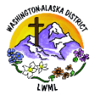
Lutheran Women in Mission
LWML Washington-Alaska District – Mission Grants March 2026

The following 2024-2026 District Mission Grants have been funded through your mites!

Concordia International Radio Saves Lives Spiritually and Physically (Grant #14). Through this Mission Grant of $2000, we assist Ministry in Mission in subsidizing the operation of Concordia International Radio in Jacmel, Haiti, a station that helps deliver the Good News Gospel to the hurting people of Haiti during a time of great upheaval. Ministry in Mission is a Recognized Service Organization of the LCMS with fifteen years of experience in Haiti. Extreme weather conditions caused Concordia International Radio’s older equipment to age more quickly. In order to ensure a continuous, quality radio broadcast, funds were needed to assist in the purchase of three laptops, three multidirectional microphones, a 16-channel mixer, three hard drives, three fans, two tape recorders, six solar panels, and a power inverter. These radio equipment upgrades will enable the continued broadcast of Concordia International Radio to the people of Haiti. Dear Lord, Wrap your arms around the people and the ministry of Concordia International Radio, that this grant can help spread the Gospel to your people in Haiti and give them strength in adversity. Amen.

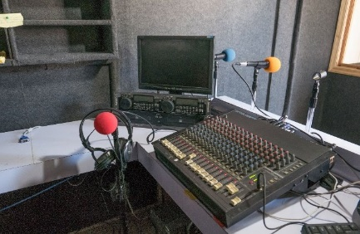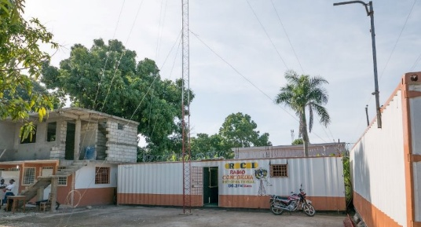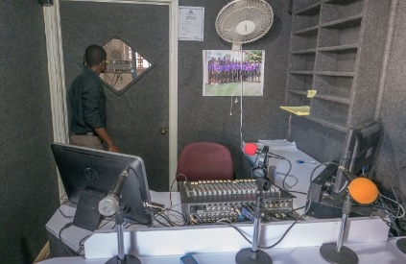

Orphan Grain Train – Reaching Out to Ukrainians (Grant #15). Orphan Grain Train has already relocated and provided assimilation and funding for Ukrainians who have fled the war in Ukraine to Norfolk, Nebraska. With this grant of $5000, Orphan Grain Train provides continued funding for the spiritual and material needs of Ukrainians displaced by war, with grant funds supporting Gospel Outreach, as well as ongoing expenses associated with relocation and assimilation into their new community. Dear God, Let Jesus’ light shine in the lives of all those displaced by the war in Ukraine. Walk with the people of Ukraine, both those in the war zone abroad and those who relocated to the United States, that they may know the love of Jesus through this mission grant. Amen.

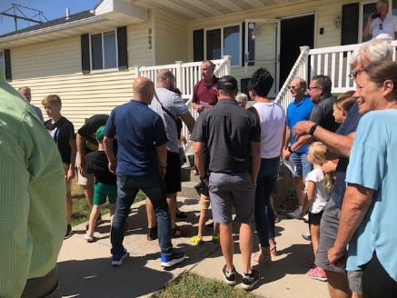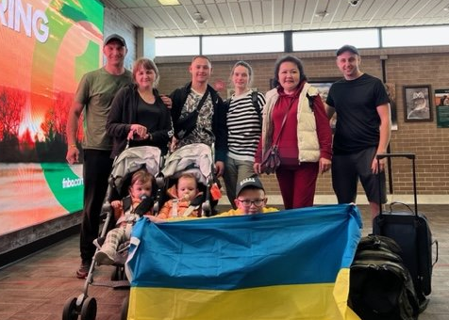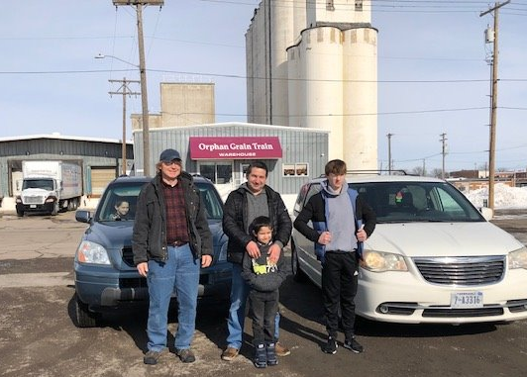

Walking Together in the Mission Field – Alliance Missionaries LCMS (Grant #16). Alliance Missionaries are pastors supported by the budget of the LCMS, either members of partner churches of the LCMS or those from countries in which mission work is beginning without a parent church body. Alliance Missionaries currently have such pastors in the Dominican Republic, Jamaica, Peru, Panama, Guatemala, Ethiopia, Uganda, Uruguay, South Africa, and undisclosed parts of Eurasia and Asia. This grant of $1500 helps fund the program “Walking Together in the Mission Field” from the LCMS Office of International Mission in support of Alliance Missionaries working alongside and together with LCMS missionaries, complementing and strengthening each other as they spread the Gospel and show mercy to hurting people. Lord Jesus, Walk with the Alliance Missionaries of the LCMS, that they may be strengthened to share the Good News with those who hunger for Your life-saving message of love, hope, and salvation. Amen.

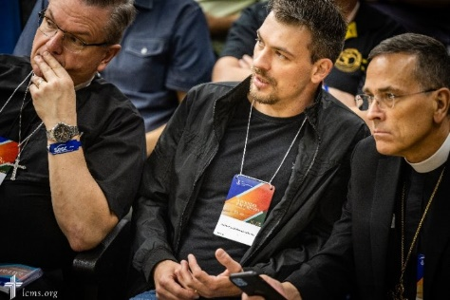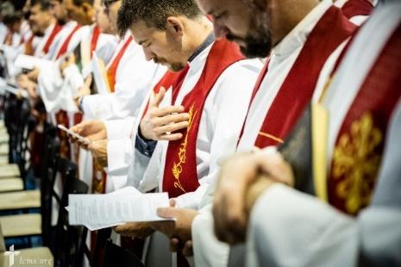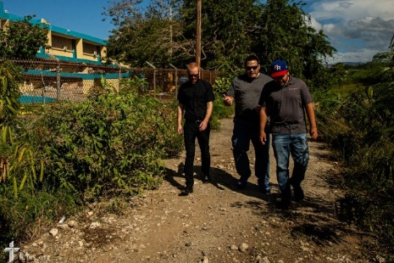

Our 2024-2026 Washington-Alaska District Mission Grants have been paid!
The Lord’s work continues! Please continue to remember our sixteen district missions in your prayers, that the Lord continue to prosper their work in God’s Kingdom for His glory. Your mites continue to pay for our thirty-three national mission grants; please pray for these missions! More information on LWML’s 2025-2027 biennium mission grants, including devotionals and prayers, can be found at lwml.org.

Yours in Christ, Solveig Schick – Mission Grant Committee Chairman

