***Mission Grant Committee***

***Solveig Schick, Chairman***

***Mites to Missions!***

Your mites help fund ministries in our nation and around the world! Through your mites, you have funded the following district mission grants:

* **Expanding Gospel Proclamation Worldwide** was funded in the amount of $1,000. This ministry gives financial assistance to international students attending Concordia Seminary (St. Louis) from developing nations. Many of these students would be unable to attend advanced-level theological degree programs at Concordia Seminary without the support of Lutheran bodies such as ours, yet are devoutly passionate, excellent students who seek to spread the Gospel message throughout the world. Lord Jesus, we pray Your blessings on these future Lutheran pastors, as they prepare to bring Your Word and Gospel to the people of many continents!

 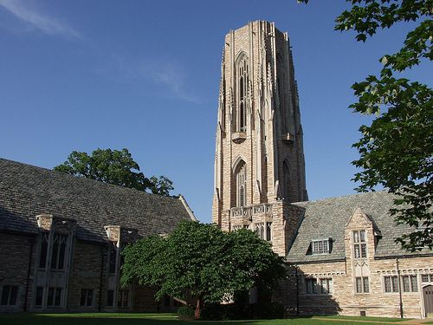 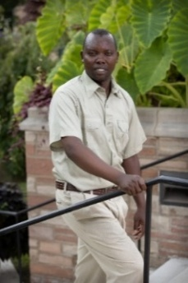

* **Orphan Grain Train – Mercy Meals** was funded in the amount of $10,000. This ministry provides low-cost, highly nutritious food for the hungry, while sharing Christian love and the Gospel with those who may not know Jesus. Mercy Meals uses volunteers to package nourishing food to be delivered through Orphan Grain Train volunteer resources; this food has touched lives in America and around the world, in orphanages, refugee camps, feeding centers, disaster relief centers, and local food pantries. The Orphan Grain Train volunteer network shares personal and material resources as a loving response to Christ’s love – in this partnership with Mercy Meals, the needs of both physical and spiritual hunger are met in Jesus’ name. Good Shepherd, we pray that You bring comfort and hope to Your people through this gift!

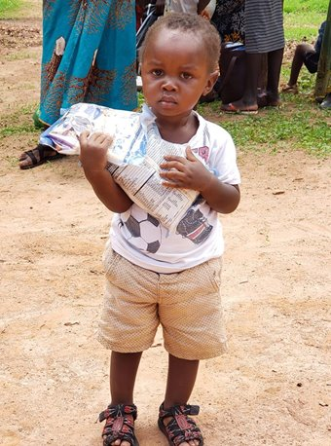 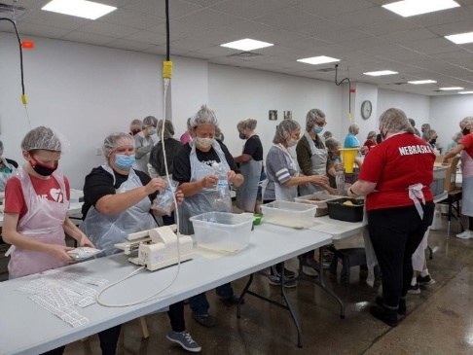 

***Continue to keep all LWML Mission Grant ministries in your prayers***, even after these grants have been paid! LWML mission grants can be found on lwml.org, WA-AK district grants are on wa-aklwml.org!

*(Continued on next page)*

**Did You Know?**

Twenty-five percent of mites collected in our Washington-Alaska district go to fund national LWML mission grants, and (Praise God!) you have made a difference! All thirty-one national missions voted on for the 2023-2025 biennium have been funded! Mites in the amount of $2,350,000 are now out in the mission field doing the Lord’s work in ministries voted on by your representatives to the 2023 LWML convention in Milwaukee! Visit lwml.org to see the new list of mission grant proposals for the LWML 2025-2027 biennium! These will be voted on soon by your representatives, with new national LWML mission grants announced at the 2025 convention in Omaha.

Yours in Christ,

Solveig Schick

Mission Grant Committee Chairman