
Bringing the Word to Light
Lutheran Braille Workers

$ 5,000

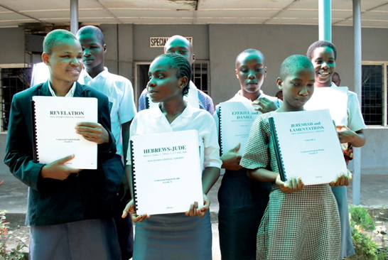
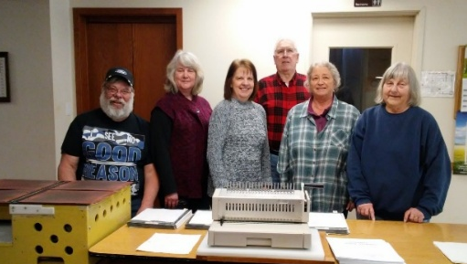
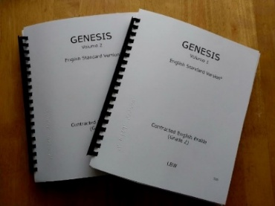

Lutheran Braille Workers bring the message and light of salvation through Jesus Christ to the blind and visually impaired, producing and distributing Bibles and other Christ-centered materials free of charge. Jesus said, “As long as I am in the world, I am the light of the world” (John 9:5).
The $5,000 mission grant will be used to purchase paper, bindings, and essential supplies for the two Braille Ministry Production Centers within our LWML District, located at St. Luke Lutheran Church in Federal Way and Immanuel Lutheran Church in Everett. These funds ensure that God’s Word continues to reach individuals and communities throughout the Pacific Northwest and beyond.
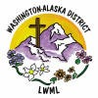
2026-2028 Biennium – LWML Washington-Alaska District

