**August 2025**

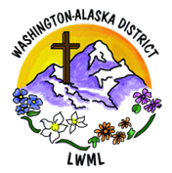**Your Recent Mite Donations Fund Three New Missions!**

Your mites help fund ministries in our nation and around the world! The following three 2024-2025 LWML Washington-Alaska District Mission Grants have been recently funded through your mites:

* **LAMP Ministry’s 55 X 55 Initiative** was funded in the amount of $1,000. Through this initiative, we assist LAMP Ministry in their cross-cultural ministry among God’s people in the most remote areas of northern Canada. Tiny communities scattered across the north are hungry for the ministry LAMP provides to children who live in these isolated and harsh conditions – LAMP’s 55X55 Initiative hopes to fund 55 trips for their 55th Anniversary in 2025. Through volunteer teams sent by LAMP Ministry, these children (and communities) learn they have an ever-present friend in Jesus and are valued in the eyes of God and all of us. Dear Lord, let Your Gospel shine as a beacon of light and hope to Your people in the North, helping all who hear it to safely navigate the shoals and challenges of modern life. Bless and strengthen all those who volunteer and serve in this important ministry.

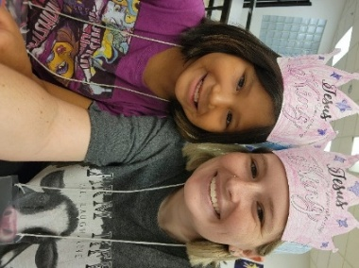 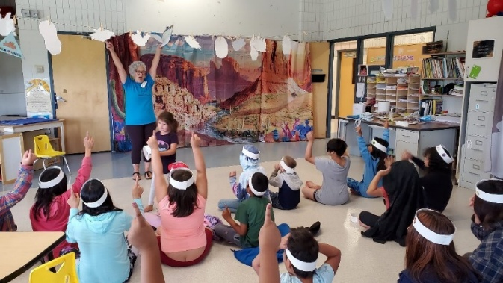 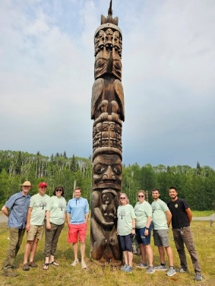

* **Lamb of God Evangelical Lutheran Church’s Strip Church Ministries** was funded in the amount of $3,000. We give thanks for this ministry where church members share the love of Jesus Christ with God’s people trapped within the sex industry in Seattle. This ministry developed out of the realization that the Lord’s mission field could be found immediately outside the church’s doors among Lamb of God’s neighbors and in answer to the question asked by parishioners: “Who is my neighbor?” With the life-saving, soul-healing Gospel of Jesus Christ, Lamb of God volunteers build positive relationships, initiate prayer groups, and provide cookies and safety items as gifts, letting the women trapped in this industry know they are not forgotten by God and His people. Dear God, we pray that Your Word and the Gospel of Jesus can engender and sustain faith in all who are touched by this ministry. Bless the volunteers, Lord, as You work through their hands, hearts, and voices to do Your work here on earth.

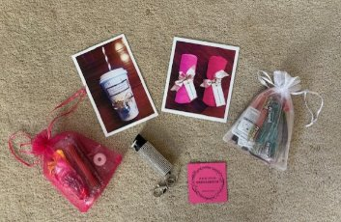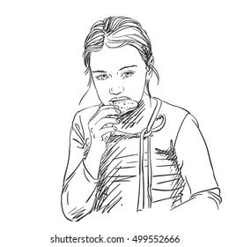 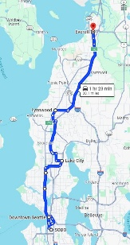 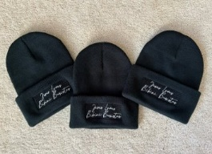

* **Lutheran Ministry Services Northwest’s Adopt a Care Center.** This mission grant of $3,500 will equip 10 additional care center ministry teams with a package of resources for volunteers to use at care centers. These resources will include large-print song books, devotion materials geared for older adults, CD’s to accompany song books and a CD player for use by those without instrument skills. Visits by these care teams make a world of difference to care center residents, many whom only receive only one or two visits per month. Through these resources, the Gospel of Jesus can shine into the lives of many, offering the comfort and perfect hope of knowing God’s Love and His plan for our salvation. Dear Lord, Bless these materials and the workers who use them to Your glory as they share the love of Jesus with those who live in care centers. Warm the hearts of all who hear Your songs of praise and Your words of comfort and hope.

 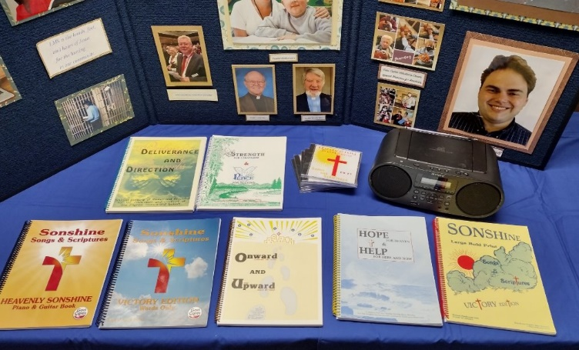

**The next mission to be funded by your mites:**

* **Feeding Haitian Children for the Kingdom through Trinity Hope.** Through this mission grant of $10,000, Trinity HOPE purchases food from Haitian vendors to provide a noon meal to children, teachers, and cooks in over 240 Christian schools. This grant will sponsor the meal program at one specific Haitian-Lutheran school, covering the overall costs for approximately 200 meals per school day for one school year. Providing a noon meal for the hungry children in our Lutheran schools in Haiti is a powerful witness used by the Holy Spirit to discredit the Voodoo teaching that God is unapproachable and non-responsive to Haitians. This ministry can be instrumental in bringing whole families to the knowledge of Christ and demonstrating the love of Jesus through word and deed. See the Mite Challenge Poster for this Mission Grant in this newsletter!

***Continue to keep all LWML Mission Grant ministries in your prayers***, even after these grants have been paid! LWML mission grants can be found on lwml.org, WA-AK district grants are on wa-aklwml.org!

The **WA-AK District Mission Grant Committee** met July 31, 2025 and approved the removal of the mission grant resolution requirement from the 2026-2028 Mission Grant Proposal Form. Solveig will announce this in the Newsletter and on the website, as well as removing the requirement on our current form. This follows guidance from LWML. The Committee also approved the Mite Challenge for our 13th 2024-2026 WA-AK District Mission Grant: Feeding Haitian Children for the Kingdom – Trinity Hope.

Yours in Christ,

Solveig Schick - Mission Grant Committee Chairman

August 2025