Mental Health Prayer Book
Higher Things
$1,300

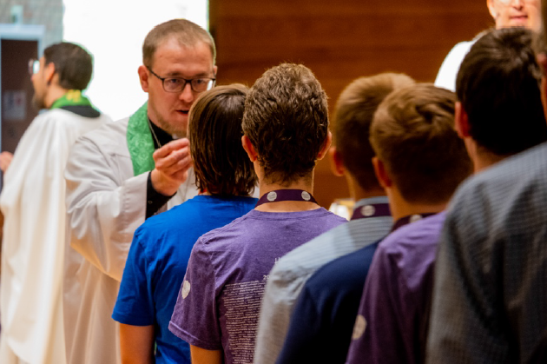

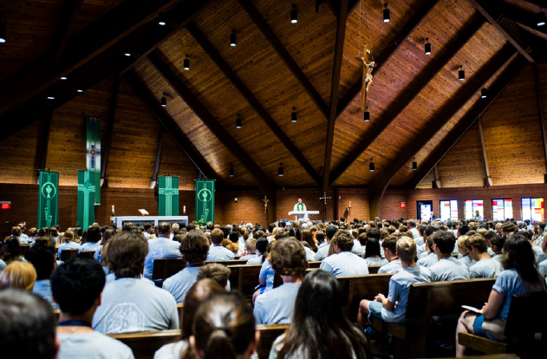

Higher Things exists to make the gifts of Christ Jesus known to youth and young adults through faithful catechesis, worship, and teaching. The mission of The Mental Health Prayer Book is to bring the comfort of the Gospel to those struggling with the burdens of mental illness and emotional suffering.
This prayer book seeks to fill the gap in faithful Lutheran devotional materials addressing mental health by offering a resource rooted in the means of grace and the certainty of God’s promises, intended for youth and young adult audiences, but accessible for all.

The $1,300 grant funds will be used to:
• Support the writing, editing, and theological review process.
• Fund printing, design, and layout costs for the initial publication.
• Provide free or discounted copies to LCMS congregations, campus ministries, and seminaries.
• Develop digital versions and companion devotional materials for online use.

2026-2028 Biennium – LWML Washington-Alaska District

