Sharing the Light of Christ
through Five LCMS Missionaries
$10,000

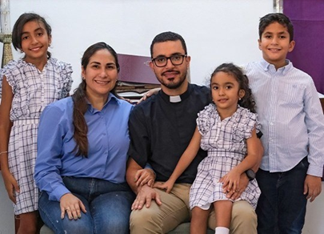
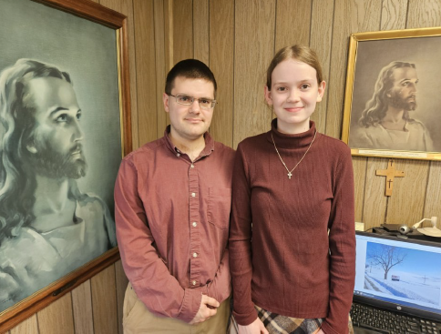
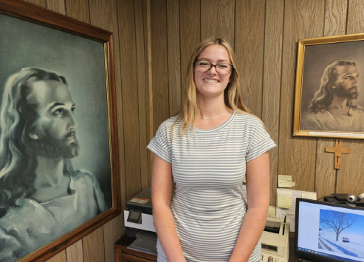

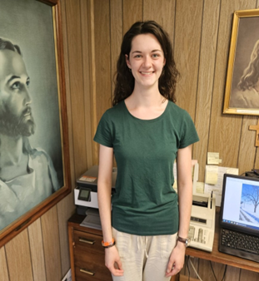
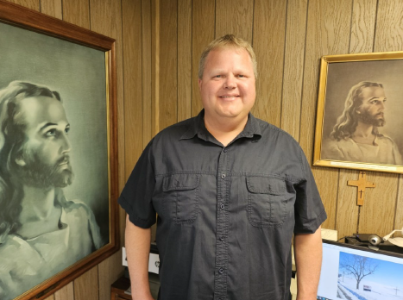

Gary Thies, Mission Development Counselor for the LCMS states, “People are eager to hear about Jesus. The challenge is great, but God has sent wonderful pastors, vicars, teachers, and missionaries to reach out to those in need.” Scripture tells us, “Your word is a lamp unto my feet and a light to my path” (Psalms 119: 105). The Lutheran Church strives to meet this urgent need by Sharing the Light of Christ through the ministries of our LCMS missionaries.
Through this $10,000 grant, five of the newest LCMS missionaries will be supported in the early stages of their ministry, each with 20% of this grant. As career missionaries, expenses will be ongoing and they will need financial support for the duration of service in the mission field. The $10,000 grant will help defray some of their many expenses over the 2026-2028 biennium.

2026-2028 Biennium – LWML Washington-Alaska District

