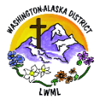
Lutheran Women in Mission Washington-Alaska District
2024-2026 Mission Grants November Update: Thank you!
Feeding Haitian Children for the Kingdom (Mission Grant #13) is fully funded!

Thank you for your generous Mite Challenge response! LWML Washington-Alaska District Mission Grant #13 of our 2024-2026 biennium is now fully funded for the amount of $10,000 through your mite donations! Trinity Hope’s mission began in Haiti in 1999 with one school and 42 children and has grown to provide 62,000 children midday meals in over 281 Christian Schools. This is a shared partnership through which each school pays approximately 5% of the costs of purchasing food from Haitian vendors and paying a cook. This Shared Support is a way for Haiti not to become too dependent on Trinity Hope, while still providing students with nutritious meals. Our LWML WA-AK district grant of $10,000 sponsors the meal program at one Haitian-Lutheran school, covering costs for approximately 200 meals per school day for one school year. Providing a noon meal for hungry children in our Lutheran schools in Haiti is a powerful witness used by the Holy Spirit to discredit the Voodoo teaching that God is unapproachable and non-responsive to Haitians. We pray this ministry is brings children and families to the knowledge of Christ, demonstrating the love of Jesus through word and deed in Haiti. Thank you, Lord, for the mission-minded dedication of your people throughout the WA-AK district who enabled the funding of this grant!

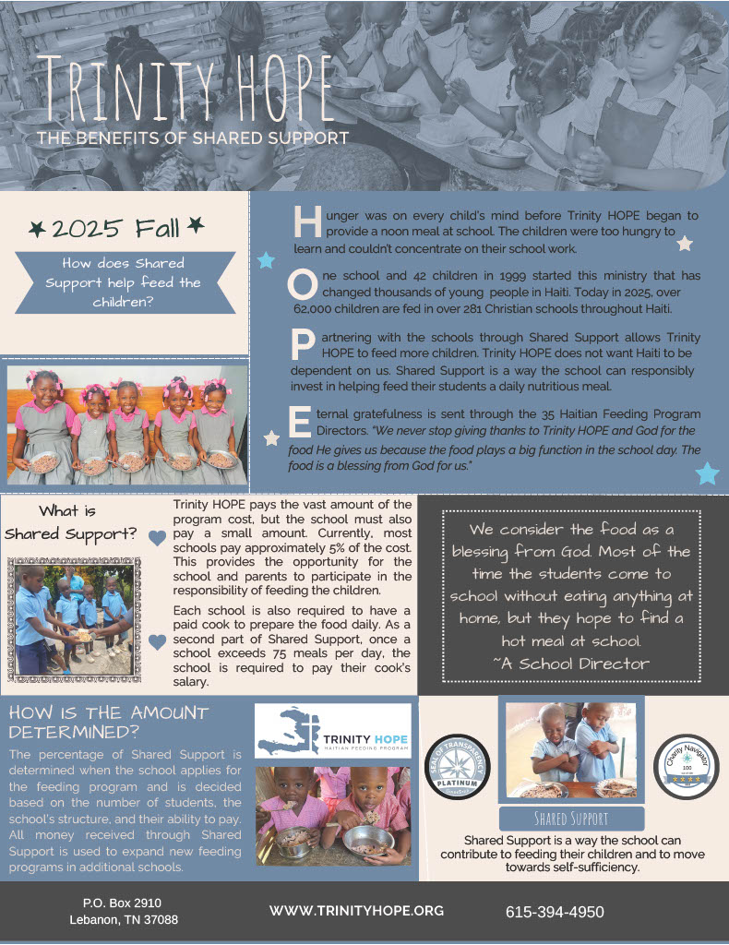

These 2024-2026 mission grants will be the next to be funded by your mites:
- Concordia International Radio Saves Lives Spiritually and Physically. Through this Mission Grant of $2000, we will assist Ministry in Mission in subsidizing the operation of Concordia International Radio in Jacmel, Haiti, a station that helps deliver the Good News Gospel to the hurting people of Haiti during a time of great upheaval. Ministry in Mission is a Recognized Service Organization of the LCMS with 15 years of experience in Haiti. Extreme weather conditions caused Concordia International Radio’s older equipment to age more quickly. In order to ensure a continuous, quality radio broadcast, funds are needed to assist in the purchase of three laptops, three multidirectional microphones, a 16-channel mixer, three hard drives, three fans, two tape recorders, six solar panels, and a power inverter. These radio equipment upgrades will enable the continued broadcast of Concordia International Radio to the people of Haiti.
- Orphan Grain Train – Reaching Out to Ukrainians. Orphan Grain Train has already relocated and provided assimilation and continued funding for Ukrainians who have fled the devastating war in Ukraine to the United States. With this grant of $5000, Orphan Grain Train will provide for the spiritual and material needs of Ukrainians displaced by war to Norfolk, Nebraska, with funding for relocation, assimilation, and ongoing expenses as well as for Gospel Outreach.
- Walking Together in the Mission Field – Alliance Missionaries LCMS. Alliance Missionaries are pastors supported by the budget of the LCMS. These men are either members of partner churches of the LCMS or men from countries in which mission work is beginning without a parent church body. Alliance Missionaries currently have such pastors in the Dominican Republic, Jamaica, Peru, Panama, Guatemala, Ethiopia, Uganda, Uruguay, South Africa, and undisclosed parts of Eurasia and Asia. Our grant of $1500 helps fund the program “Walking Together in the Mission Field” from the LCMS Office of International Mission in support of Alliance Missionaries working alongside and together with LCMS missionaries, complementing and strengthening each other as they spread the Gospel and show mercy to hurting people.
Yours in Christ, Solveig Schick – LWML Washington-Alaska District Mission Grants Committee Chairman

