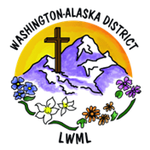

LWML WA-AK District Mission Grant

**$10,000 Mite Challenge!**

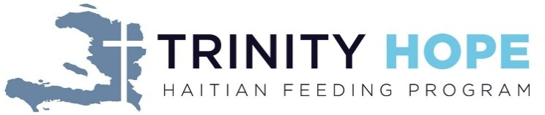Feeding Haitian Children

for the Kingdom **Trinity HOPE**

**The LWML WA-AK District Mission Grants Committee is asking zones and groups**

**to consider having a special offering for mites in place of a traditional Ingathering during upcoming Fall events to fund this year-long program of school meals!**

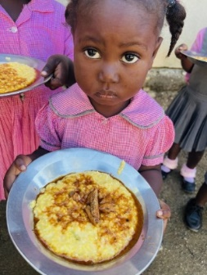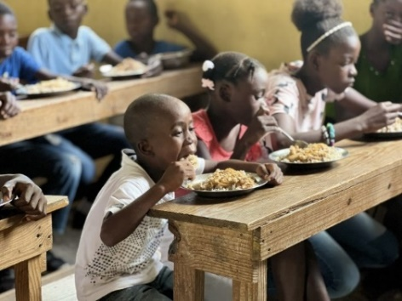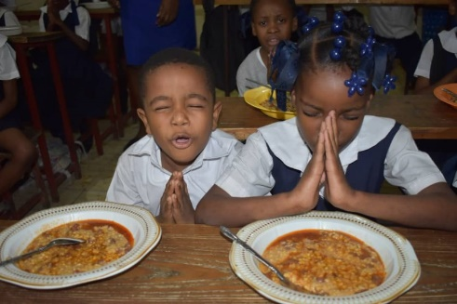

Trinity HOPE purchases food from Haitian vendors to provide a noon meal to children, teachers, and cooks in over 240 Christian schools. The grant money is designated to one specific Haitian-Lutheran school to sponsor the feeding program at that school. The grant covers overall costs for approximately 200 meals per school day for one school year. Providing a noon meal for the hungry children in our Lutheran schools in Haiti is a powerful witness used by the Holy Spirit to discredit the Voodoo teaching that God is unapproachable and non-responsive to Haitians. This ministry can be instrumental in bringing whole families to the knowledge of Christ and demonstrating the love of Jesus through word and deed.

8/25