Changed Lives, Shared Word
Lutheran Bible Translators
$2,500
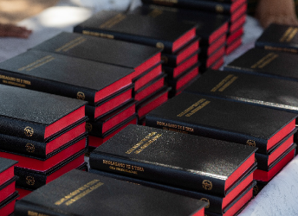
_____________________________
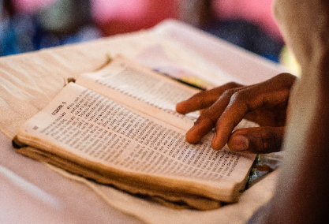
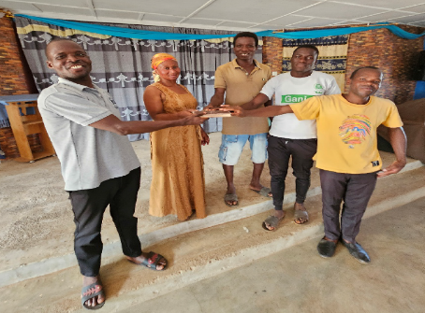
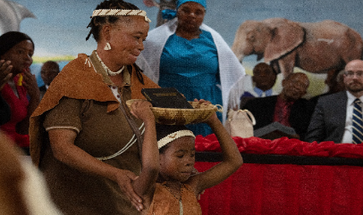

With 5-7 new Bible translations expected in 2027, the need for printing support is urgent. Each Bible costs approximately $20 to print; this $2,500 grant will fund 125 additional copies and help bolster the printing fund producing these Bibles.
The ministry of LBT impacts thousands of individuals through Bible distribution, literacy workshops, and Scripture engagement events. Families receive their first Bible; pastors preach in their native tongue; and children and adults learn to read using Scripture and Scripture-based materials.

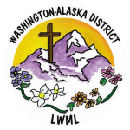
2026-2028 Biennium – LWML Washington-Alaska District

