Healing the Whole Child Bike Path
Dakota Boys and Girls Ranch
$2,000

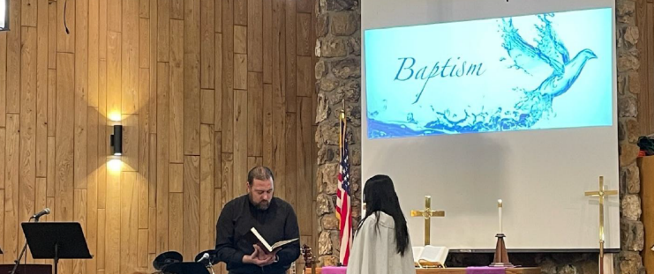
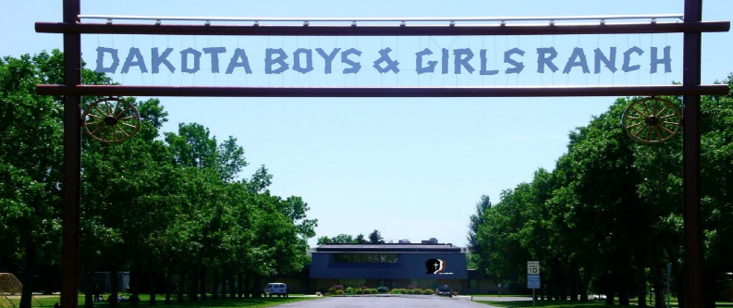

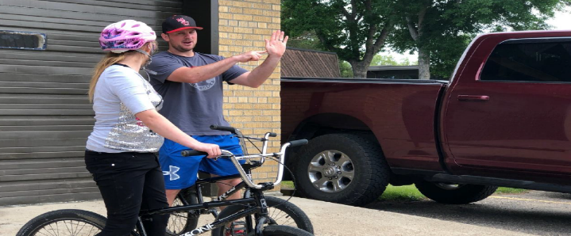
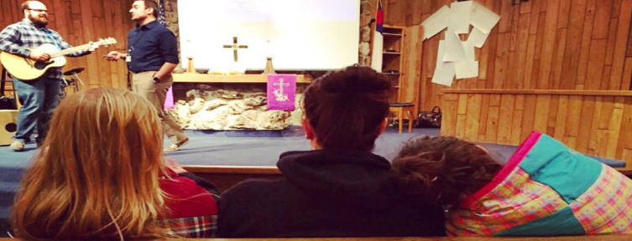

The mission of Dakota Boys and Girls Ranch is to help at-risk children and their families succeed in the name of Christ. The goal of this mission grant is to improve treatment outcomes, and support the physical, mental, social, and spiritual well-being of children at Dakota Boys and Girls Ranch through robust wellness programming.
The $2,000 mission grant will support critical Wellness Programming at Dakota Boys and Girls Ranch. Funds will be used to construct a bike path on the Minot campus which currently does not exist. Currently, the only option is for kids and staff to ride around the parking lots and other areas of campus where cars typically drive. The new bike path will give kids a safe place to enjoy the benefits of physical activity.
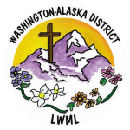
2026-2028 Biennium – LWML Washington-Alaska District

