
Lutheran Women in Mission – LWML Washington-Alaska District
July 2026 Mission Grants Update

How exciting to begin a new biennium of missions that spread the Gospel and Word of God to our communities, our nation, and our world! District mission grants selected at the 2026 LWML Washington-Alaska District Convention in Spokane for the 2026-2028 biennium (see the Mission Prayer List!) will be funded in the order determined by the votes of convention delegates as mites are collected by LWML groups, zones, and congregations, with District Scholarships and Short Term Missions funded as needed throughout the biennium.

Fall 2026 Scholarships of $1000 have been sent to colleges of scholarship recipients in our district dedicating their studies to future church work. Please keep these scholarship recipients in your prayers as they begin their fall semester, that the Lord bless their studies and increase and strengthen their faith to His glory: Eric Breidert, Ryan Stites, Isaac Stults, and Kelsie Wiley.

You are funding missions through your mites! The following district mission grant is the next to be funded by the LWML Washington-Alaska District:

Worker Wellness for Chaplain Wives/Families – Twice a year, LCMS’s Ministry to the Armed Forces hosts chaplain training events that provide worship, fellowship, theological study, and guidance on religious liberty issues. These gatherings strengthen chaplain wellness, keep them connected to their church body, and prepare them to better care for military personnel and their families. Recognizing the vital role of chaplain spouses, MAF has expanded these events to include them. Chaplain wives face the dual challenge of military life and church-worker isolation, often without strong peer networks. Participation in this retreat provides encouragement and Christ-centered fellowship with other spouses who share their unique calling, strengthening this vital mission to the Armed Forces. This $5,000 grant will help cover travel expenses so spouses can share in the Worker Wellness program for chaplains, allowing this retreat to benefit the whole chaplain family.

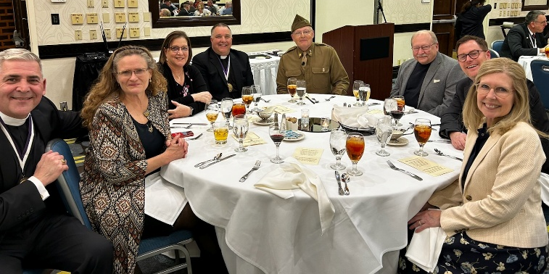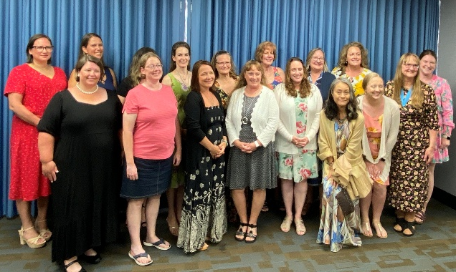

Yours in Christ,
Solveig Schick – Chairman of Mission Grants Committee

