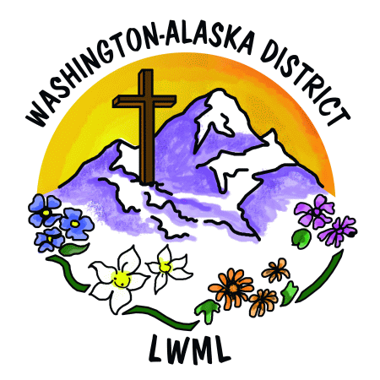

2026 LWML Washington-Alaska District Convention Offering Proposals

- Showers of Blessings – Faith Lutheran LWML in Sequim, Washington began a “Loads of Love” ministry at a local laundromat two years ago and would like to add a “Showers of Blessings” ministry. The local laundromat offers a shower service of $10 for a timed shower. Towels are provided by the laundromat for this price and, if returned, a refund of $5 is given. “Showers of Blessings” would be offered during the two hours per week that the church offers our “Loads of Love” ministry at the laundromat, when LWML and church volunteers from Faith Lutheran are present in the laundromat. Many encounters at the laundromat spark conversations about faith and Jesus’ love; showers are one more way to offer dignity and hope to those being served. [Faith Lutheran LWML, Sequim, WA]

- Community Easter Egg Hunt – Since 2009, Epiphany Lutheran Church in Kenmore, Washington has held an annual community Easter Egg Hunt the day before Easter. This event reaches out to the local community with the news that Christ has Risen! There are Easter egg hunts for children ages 3 to 11, as well as crafts, snacks, movies about the Easter story, and CPH books for children. Last year, 700 people from the area attended the event; this year, more than 1,400 participated. An intergenerational group of volunteers help stage this Easter celebration. Epiphany Lutheran church members work hard throughout the Lenten season to fill eggs with candy and toys that are reminders of God’s love, and this offering would help with the increasing expenses. [Epiphany Lutheran Church, Kenmore, WA]

