**How Can our Mites be Used to Share the Love of Jesus?**

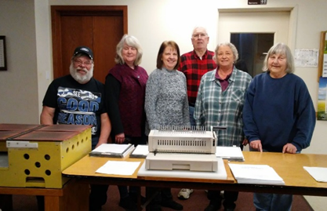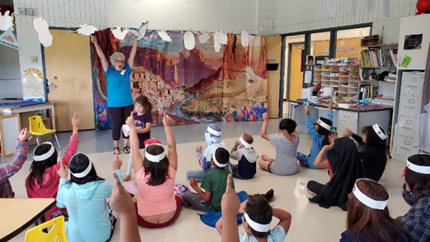

**Is the Holy Spirit Calling You to Support a Mission?**

**Check out the LWML WA-AK District Mission Grant Proposal Application Online at *wa-aklwml.org!***

2026-2028 Biennium Mission Grant Proposals are due October 31, 2025

**Important Note:**

*After discussions with LWML, LWML WA-AK District no longer requires* ***Resolutions*** *to be part of the mission grant application. See the updated Proposal form online!*

**Who can apply for an LWML WA-AK District Mission Grant?**

***Any LWML member, group, or zone may submit a Mission Grant Proposal for consideration by our Mission Grants Committee for the upcoming 2026-2028 LWML WA-AK District Biennium!*** *Additionally, we also accept mission grant proposals from any ministry of the Office of International Mission, the Office of National Mission, or the Office of the President of the Lutheran Church – Missouri Synod (LCMS).*

**Is the Application Hard?**

***Application questions are straightforward and emphasize the mission-focused work of sharing the Gospel of Jesus Christ.*** Contact any member of the Mission Grants Committee with questions about supporting a mission grant! ***We would be happy to help!***What ministries do you feel called to support in our 2026-2028 Biennium?

Yours in Christ,

Solveig Schick – VP of Gospel Outreach, LWML Washington-Alaska District