Worker Wellness
for Chaplain Wives/Families
LCMS Ministry to the Armed Forces
$5,000

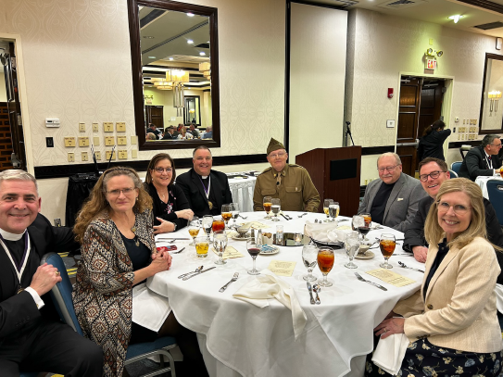

Twice a year, Ministry to the Armed Forces hosts chaplain training events that provide worship, fellowship, theological study, and guidance on religious liberty issues. These gatherings strengthen chaplains’ wellness, keep them connected to their church body, and prepare them to better care for military personnel and their families. Recognizing the vital role of chaplain spouses, MAF has expanded these events to include them. Chaplain wives face the dual challenge of military life and church-worker isolation, often without strong peer networks. Participation in this retreat provides encouragement and Christ-centered fellowship with other spouses who share their unique calling, strengthening this vital mission to the Armed Forces.
This $5,000 grant will help cover travel expenses so spouses can share in the Worker Wellness program for chaplains, allowing this retreat to benefit the whole chaplain family.
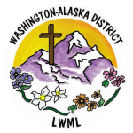
2026-2028 Biennium – LWML Washington-Alaska District

