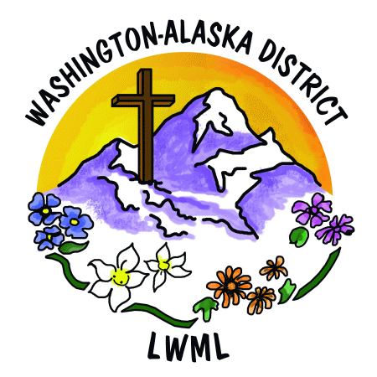
LWML Washington-Alaska District
2026-2028 Biennium Mission Grant Prayer List

 | Pray for Missions in Washington, Alaska, America, and the World | Grant
1 | Aid to LWML Washington-Alaska District Scholarships | $16,000
2 | Aid to LWML Washington-Alaska District Short Term Missions | $5,000
3 | Worker Wellness for Chaplain Wives/Families – LCMS Ministry to the Armed Forces | $5,000
4 | Bringing the Word to Light – Lutheran Braille Workers | $5,000
5 | Expanding Comfort Dog Ministry – Redeemer Lutheran Church, Spokane Valley, Washington | $5,000
6 | Emergency Response Fund for Idaho Comfort Dog Ministry – Christ the King Lutheran Church, Coeur d’Alene, Idaho | $5,000
7 | Hope for Suicide Awareness, Intervention, & Postvention – Lutherans for Life – Word of Hope | $5,000
8 | Equipping and Sending Village Mission Teams with the Gospel – Alaska Mission for Christ | $5,000
9 | House of Mercy Mission – Lutheran Ministry Services Northwest | $5,000
10 | Second Harvest Ministry to Hungry Families in Ferry County – Trinity Lutheran Church, Republic, Washington | $4,000
11 | Healing the Whole Child Bike Path – Dakota Boys and Girls Ranch | $2,000
12 | Sharing the Light of Christ through Five LCMS Missionaries – Mission Central, LCMS Mission Advancement | $10,000
13 | Changed Lives, Shared Word – Lutheran Bible Translators | $2,500
14 | Christian Library Books for Sunbeams – Lutheran Church of the Cross, Kent, Washington | $1,200
15 | Feet on the Ground – MOST Ministries | $3,000
16 | Mental Health Prayer Book Ministry – Higher Things | $1,300
 | LWML Washington-Alaska District Mite Goal 2026-2028 | $80,000

