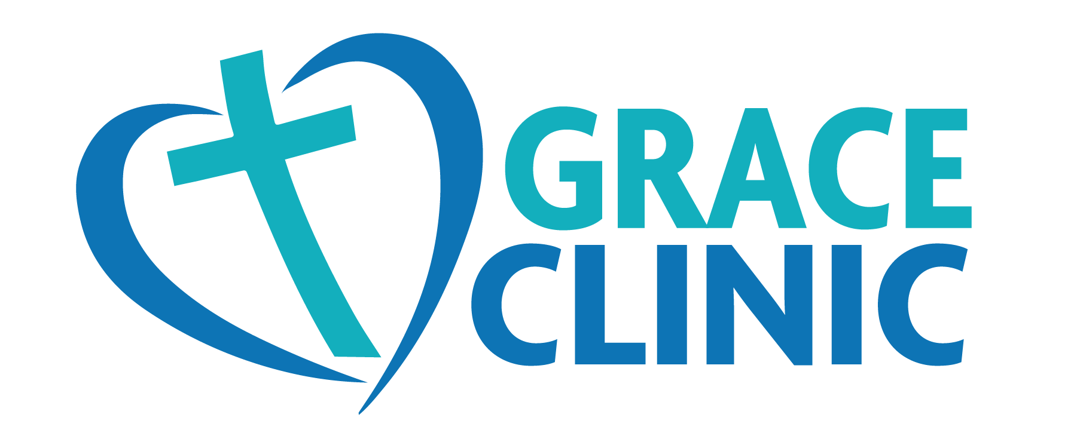

The Tri-Cities only free clinic

Grace Clinic provides free medical, dental and mental health services to uninsured adults in the Tri-Cities. Matthew 25:34-36

Our LWML WA-AK district ingathering is for this Clinic. The following items are on their list:

* NITRILE Exam Gloves (all sizes especially medium — no latex)
* Copy Paper
* Postage Stamps
* Disinfecting Wipes (with Clorox)
* Kitchen Size Plastic Trash Bags
* Hygiene Items (shampoo, body wash, toothpaste – must be unexpired, unopened, unused)
* Gift Cards to Costco, Walmart, Amazon or Office Depot