Emergency Response Fund
for Idaho Comfort Dog Ministry
Christ the King Lutheran Church
Coeur d’Alene, Idaho
$5,000

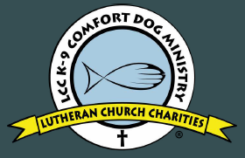

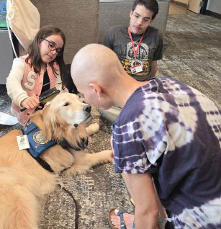

A Lutheran Church Charities Comfort Dog was placed at Christ the King Lutheran Church in Coeur d’ Alene, Idaho in late-spring 2026 to begin providing the mercy, compassion, presence, and proclamation of Jesus to those who are suffering and in need within the North Idaho region and beyond.
Although all comfort dog services are free, this $5,000 mission grant will establish a fund for emergency deployments to natural disasters (such as forest fires) or sudden emergencies (such as tragic shootings or death) by covering travel expenses for the comfort dog and their human handler, allowing them to comfort the hurting and share the Gospel when and where God’s people need it most.

2026-2028 Biennium – LWML Washington-Alaska District

