Equipping and Sending
Village Mission Teams with the Gospel
Alaska Mission for Christ
$5,000








The goal of Alaska Mission for Christ is to strengthen Gospel outreach throughout rural Alaska by equipping and sending volunteer mission teams into remote villages with the Word of God.
The $5,000 mission grant will be used to recruit, train, and spiritually equip volunteer mission teams to share the Gospel, extending the ministry of the Word to people in remote regions of Alaska who are hungry for Christ’s love. The mission grant will also enable travel, shipping, and logistics for village mission teams and provide Bible-based curriculum, devotionals, and Gospel-centered resources to volunteers for distribution within the villages.

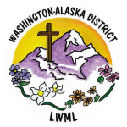
2026-2028 Biennium – LWML Washington-Alaska District

