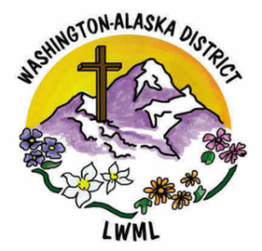

Aid to Washington-Alaska District Women for Short-Term Missions
$5,000
___________________________________________________________________________________________________


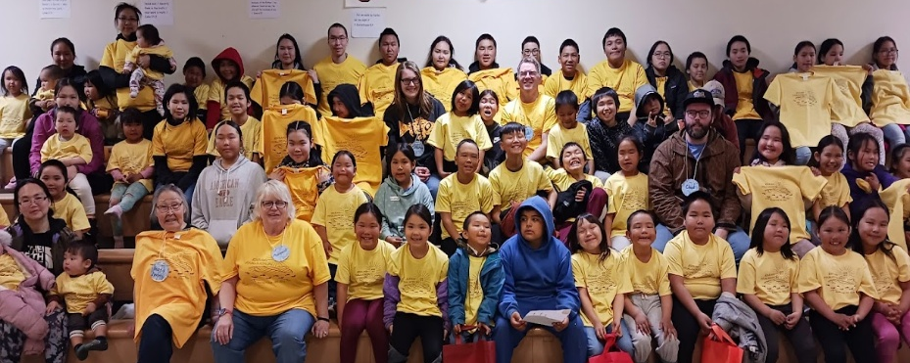

For the 2026-2028 biennium, a grant of $5,000 will be used to fund short-term mission requests from district women during the course of the biennium.
Each request is usually funded in an amount between $500 and $1,000. It is possible, then, that five to ten short-term mission requests could be partially or totally funded during the biennium. The decision to accept a request for financial assistance will be made by the Short-Term Missions Committee, under the Gospel Outreach Department.

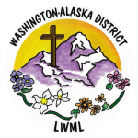

2026-2028 Biennium – LWML Washington-Alaska District

