
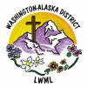
Aid to Washington-Alaska District Scholarship Fund
$16,000
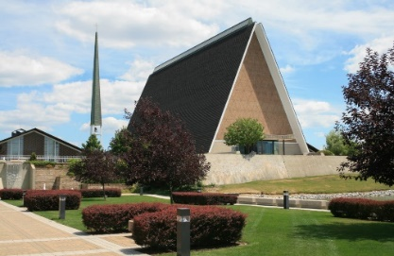
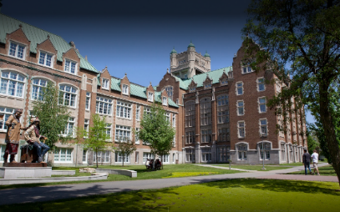
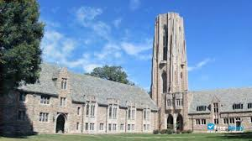

The LWML Washington-Alaska District assists students from congregations in our district who study for full-time church work and are enrolled at LCMS seminaries, universities, and colleges. Scholarship grants of up to $2,000 (undergraduate) and to $3,000 (pastoral, deaconess graduate programs) per year are sent directly to the LCMS seminary, university, or college on behalf of the applicant. The Scholarship Committee accepts applications in April for the following school year, and applicants are selected based on the student’s planned course of study and financial need, with approval granted by the district’s Executive Committee.





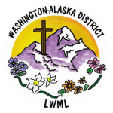
2026-2028 Biennium – LWML Washington-Alaska District

