Hope for Suicide Awareness,
Intervention, & Postvention
Lutherans for Life – Word of Hope
$5,000
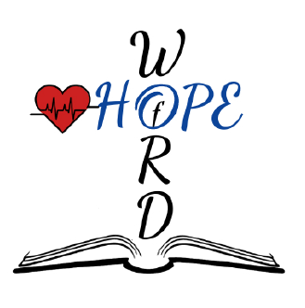




Lutherans For Life (LFL) equips Lutherans and their neighbors to be Gospel-motivated voices for life. Since 1977, Lutherans for Life has united Lutherans nationwide to apply Scripture and Lutheran doctrine to life issues, offering a joyful and hopeful response to cultural pressures that promote death as a solution to suffering.
The mission of this grant is to develop and implement the HOPE for Suicide Awareness, Intervention, and Postvention (HOPE S-AIP) program—a professional, Gospel-centered training initiative designed to equip lay people, church leaders, and congregations with practical tools and spiritual care strategies for addressing suicide. The $5,000 mission grant will help with the funds for curriculum development, video production, graphic design, and the creation of a comprehensive online platform to ensure accessibility at minimal cost, ensuring that those in crisis receive both practical help and the ultimate comfort of the Gospel.

2026-2028 Biennium – LWML Washington-Alaska District

