Christian Library Books for Sunbeams
Lutheran Church of the Cross
Kent, Washington
$1,200
_____________________________
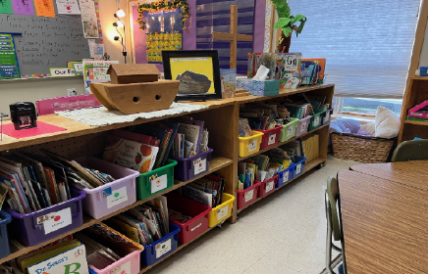
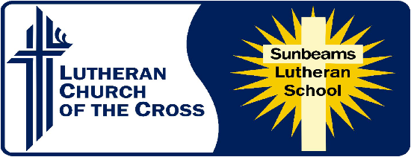
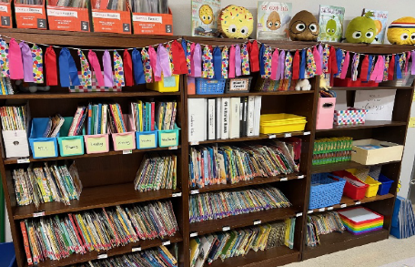

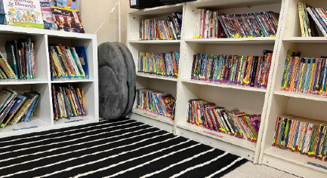

Sunbeams Lutheran School has been an active mission outreach of Lutheran Church of the Cross (LCMS) for 48 years, providing families with Christ-centered, quality education for children from preschool to fifth grade.
The Scripture-based library books purchased with this $1,200 grant will provide better opportunities to share the Gospel with children of all ages and reading abilities.

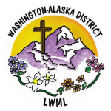
2026-2028 Biennium – LWML Washington-Alaska District

