House of Mercy Mission
Lutheran Ministry Services Northwest
$5,000
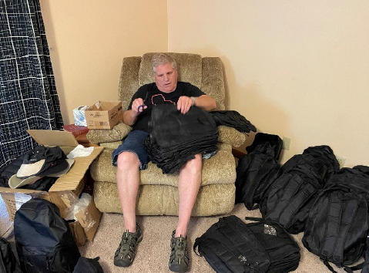
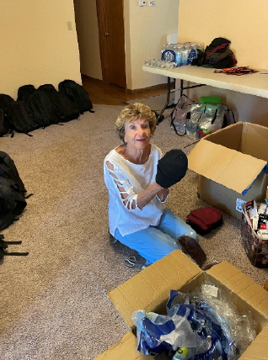
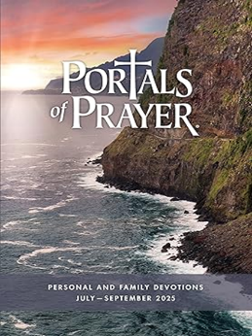
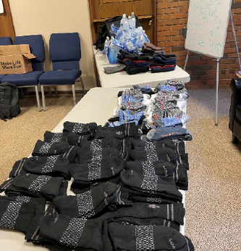

Established in 1938, Lutheran Ministries Services Northwest is an extension of all Lutheran congregations in the Pacific Northwest. Lutheran Ministries Services Northwest provides Christian pastoral care in area hospitals, care centers, jails, and prisons. They also serve as the prison/jail ministry coordinators for the Northwest District of the LCMS. Lutheran Ministries Services Northwest is the hands, feet and heart of Jesus for the hurting in our community.
This $5,000 mission grant will be used to equip men recently released from incarceration and residing at the House of Mercy with essential clothing and grooming items that foster confidence in daily activities—from grocery shopping to job interviews—supporting their journey toward reintegration and self-sufficiency. Grant monies may also be used to distribute the Portals of Prayer to prisons and jails.

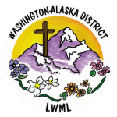
2026-2028 Biennium – LWML Washington-Alaska District

